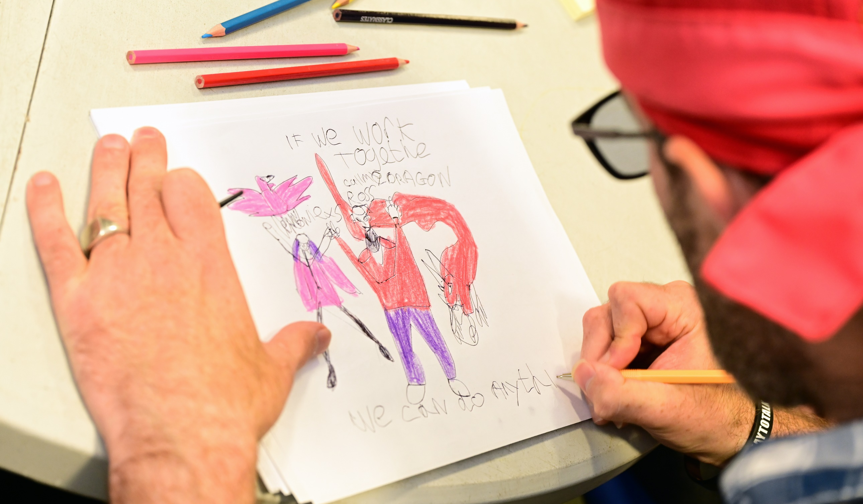

Learning Disability Strategy
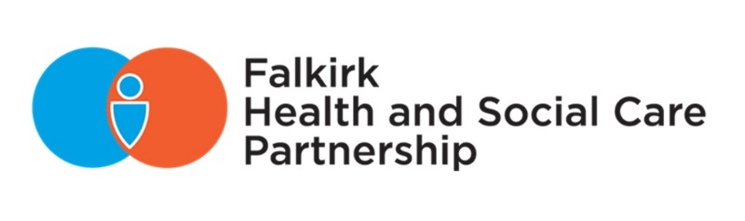
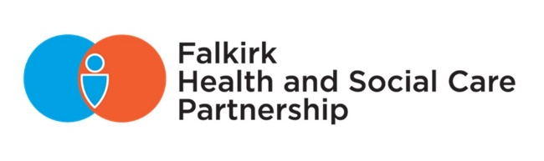
Engagement Feedback

Introduction

The Falkirk Learning Disability Team (FLDT) have been developing a five-year strategy and delivery plan to improve outcomes for people living with learning disabilities in the Falkirk area. As part of this work, we engaged with people with learning disabilities, their carers and families, and staff to help inform the strategy and the development of local learning disability services.

The first phase of engagement (27 May – 21 June) included staff feedback on the draft delivery plan. This involved asking for views at the FLDT staff development day on 6 June and staff survey on Participate+ where we received seven responses from staff (Falkirk Council, NHS, independent care provider, and third sector) and two responses from members of the public.

The Learning Disability Conversation Cafés (18 and 19 June) held at Camelon Social Work Office invited people with learning disabilities and their carers, family members, and support workers to share their views, draw pictures for the cover page, and suggest names for the strategy. We engaged with 26 people across both events and asked them to share what it is like to be them and what could be better.

The final phase of engagement (5 August – 18 September) will involve presenting the draft strategy and delivery plan to people with learning disabilities, their carers and family members, and staff. A survey will be available on Participate+ where people can provide feedback and vote on their favourite name and cover picture for the strategy. We will be hosting a drop-in session at Camelon Social Work Office on 7 August, 11am-2pm for people to come along to give their views on the draft Learning Disability Strategy as well as the draft Digital Health and Care Delivery Plan. The Carers Voice Group on 16 September at Falkirk & Clackmannanshire Carers Centre will provide an opportunity to speak directly with carers. We will also be speaking with providers and local community groups to seek their views.

Feedback from engagement will support the development of the final strategy and delivery plan which will be presented to the Integration Joint Board (IJB) on 29 November 2024 for approval.

You Said, We Did

“Important to get out and about.”
Opportunities to socialise with friends and family, participate in activities, and going on holiday are all important to people with learning disabilities. Examples of activities people enjoy, include bowling, cinema, Elgin Park, football, cooking, bingo, going out for dinner, and shopping. Many talked about the importance of meeting with friends and family, as well as their relationship with trusted professionals, e.g., their support worker or dentist.

However, there continues to be a demand for more opportunities to get involved in activities as well as make new friends. People want more opportunities to go away for day trips and holidays. They want more groups like a reading group, swimming group, or women’s group, where they can make new friends. Meeting new people and having opportunities to socialise and build relationships is important. However, it can be challenging for some so individuals may benefit from having additional support from staff to help them get out of the house and meet new people.

Examples of actions from Delivery Plan:
- We will work with partners to improve access to public transport for people with learning disabilities. (No. 38)
- We will provide support for smaller community and third sector groups to improve outcomes for people with learning disabilities. (No. 40)

“Sometimes I don’t want support and just want to be independent.”
People with learning disabilities want to be independent, have choice and control over their own life, including being able to control their own money and their own home, and to be given support and advice when they need it. People want to be seen as they are, not what other people want. They want to be happy and for their voice to be heard.

To better support people to be independent and get involved in their local communities and participate in activities, people will need access to Changing Places Toilets across the Falkirk area, support to access public transport, and better facilities for people with disabilities.

The vision for the Falkirk Learning Disability Strategy is: “People with learning disabilities feel supported to live independently with choice and control over their own health and wellbeing.” The priorities and outcomes this strategy sets out aims to achieve this vision so people with learning disabilities can be independent and know what support is available and how to access it when they need it.

Examples of actions from Delivery Plan:
- We will raise awareness of available opportunities to support people to be independent, e.g., funding. (No.??)
- We will continue to identify suitable locations and increase access to Changing Places Toilets in the Falkirk area. (No.??)
- We will find a better suited and accessible building for Learning Disability services to utilise and expand on where people with learning disabilities feel safe and have choice and control. (No. 39)

“I’d like a job in a kitchen or ASDA but it’s hard for people with a learning disability to get a chance.”
People with learning disabilities want to be employed, but it can be hard for them to get a job, and this can affect their confidence. As such, we need better opportunities for inclusion in employment and volunteering.

Examples of actions from Delivery Plan:
- We will make education opportunities available for people with learning disabilities. (No. 32)
- We will work with partners to improve access to employment and volunteering opportunities. (No. 36)
- We will work with partners to improve access to college opportunities for young people transitioning from school and adults. (No. 37)

“Celebrate diversity and inclusion. Stop having separate places – invest in more inclusive spaces.”
Everybody is different but people don’t want separate spaces away from their local communities. Falkirk needs to be more integrated and more inclusive so people can form more meaningful connections with others.

One of the priorities for the Falkirk Learning Disability Strategy is to establish a Learning Disability Friendly Falkirk so people with learning disabilities have a sense of belonging and can form connections to their local community to improve their health and wellbeing (Outcome 4). Part of this work will be to raise awareness and provide training so there is a greater understanding amongst staff of people’s different needs.

Examples of actions from Delivery Plan:
- We will develop and deliver Learning Disability awareness raising training to social work locality teams and new social work staff. (No. 29).
- We will develop a Learning Disability awareness module on OLLE and TURAS accessible to all staff.
- We will provide adaptive and alternative formats of information options when accessing services to suit people’s individual needs and preferences. (No. 41)

“As a parent carer, I’m tired. Feels like everything is a battle. Nothing comes easy – fight for school place, fight for school transport, fight for diagnosis, fight for an assessment, fight for a good SDS package, fight for inclusive employment, fight for inclusion and representation – I’m tired of fighting!”
More support for carers is needed. Carers are exhausted and have worries and fears for the future of the person they care for. Carers are finding managing the behaviour of the cared for person challenging and this is having an impact on their own wellbeing, especially when they are the primary carer.

A big topic of conversation was the need for more local respite in Falkirk and review of day services. Carers are frustrated with being repeatedly assessed by social work to access respite. They highlighted problems with the social work assessment process, for example, carers don’t know why they are being assessed, are resentful of multiple assessments, they don’t want to be telling the same story over and over again, and due to the high social work staff turnover, there is no continuity of social workers. Carers also mentioned wanting a more joined up approach between services, e.g., social work and day centre, as they feel the impact of services not working in partnership with one another and the lack of communication between services.

There is a need for improved communication and better information about what services are available, staying informed and up to date, getting the right information to people, and keeping in touch with carers, e.g., referral status. Carers recognised the impact on siblings and suggested more information for siblings and creating family support groups.

The Falkirk Carers Strategy 2023-2026 aims to support and improve outcomes for carers. The Carers Strategy Group oversees the implementation of the Carers (Scotland) Act 2016 in Falkirk and the local strategy. This group has responsibility for commissioning and overseeing activity supported by the Government funding that accompanies the Act. Outcome five of the Falkirk Learning Disability Strategy is “carers and family members feel supported to continue in their caring role.” As such, the Falkirk Learning Disability Team Manager is a member of this group to ensure carers of people with learning disabilities and their specific needs are represented in discussion around supporting carers.

Examples of actions from Delivery Plan:
- We will continue to review our day services and respite. (No. 17)
- We will expand the Neighbourhood Networks Day Support Service. (No. 34)
- We will improve and support carers to access respite provision in a variety of options to suit the needs of carers. (No. 44)
- We will signpost carers to the Falkirk & Clackmannanshire Carers Centre for support and information. (No. 45)
- We will be represented on the Carers Strategy Group to support the delivery of the Carers Strategy and raise awareness of the needs of carers looking after someone with a learning disability. (No. 43)
- We will strengthen referral pathways between social work teams and specialist teams. (No. 10)
- We will develop information documents to equip everyone with an understanding of a range of topics to support people before making a referral. (No. 26)

“Said this enough time that I just think… what’s the point?”
Carers are experiencing engagement fatigue. They don’t feel listened to and see engagement as a “waste of time”. They have become “disillusioned with Falkirk Council and social work” and don’t believe anything will change as an outcome of engagement. However, some carers wanted more engagement focused on co-production rather than consultation. They want engagement to be part of the evaluation and feedback process, not just for strategy development. Carers want more representation at policymaking level that isn’t tokenistic.

Falkirk HSCP Participation and Engagement Strategy 2024-2027 outlines how the Partnership involves and actively engages with staff, individuals, and communities in the design and development of health and social care within the Falkirk area. Key areas of focus for the next three years include increasing our representation of people with lived experience and providing opportunities for people to get involved in operational and strategic meetings to co-design services and strategies alongside staff. Work is currently underway to develop a package of training for Carer Representatives, in partnership with the Falkirk & Clackmannanshire Carers Centre, to increase our representation of carers who can get involved in strategic planning groups. This training will be made available for carers of people with learning disabilities so they can get involved at a policy-making level within the HSCP that is more meaningful.

Examples of actions from Delivery Plan:
- We will establish a Learning Disability Strategy Group with representation across services to improve partnership working and implement the Learning Disability Strategy. This Group will also include service user and carer representation. (No. 7)
- We will continue to meaningfully engage with service users and their carers/family members and listen to their views to help shape services. (No. 8)

“Need to promote the value of social care in Falkirk – show it as an investment rather a burden.”
For change to happen, we need a strong workforce with the right skills and the right passion to implement change. People have told us that we need more staff, and we need to value them. A key priority for this strategy is workforce. Achieving this priority will involve investing in training our workforce so they have the right skills and passion to support people with learning disabilities as well as improved integration and partnership working across sectors, services, and teams (Outcome 1 and 2).

Examples of actions from Delivery Plan:
- We will deliver training to upskill the workforce, so people get access to the right professional at the right time with the right skills and knowledge to support service users. (No. 3)
- We will raise awareness and increase the visibility of the Learning Disability Team. (No. 6)

Additional areas of improvement:
- Self-Directed Support
- Transitions start earlier – nursery to primary
- Information about guardianship for families and professionals, e.g., GPs.
- Waiting times to access services

Examples of actions from Delivery Plan:
- We will develop a Transitions Policy and pathway between Children’s Services and Adult Services. (No. 11)
- We will improve support for people with learning disabilities during all transition periods and between services, e.g., child to adult, hospital to community. (No. 20)
- We will continue to develop and build upon the Big Plan approach. (No. 35)

