Business Initial Engagement Summary
Introduction
Engagement and consultation with local businesses was undertaken to inform the Falkirk Council Parking Strategy. The following engagement techniques were used to gather feedback from businesses:
- Online business engagement and consultation survey (live from 21st November 2024 – 13th January 2025).
- 2 business drop-in sessions in Falkirk town centre (8th January 2025 08:00-10:00 and 9th January 2025 15:00-17:00).
- Impromptu visits to businesses in Falkirk town centre throughout the 8th and 9th January 2025.
The purpose of this exercise was to understand existing parking behaviour and the parking requirements of local businesses, whilst also identifying the key parking-related problems and opportunities relevant to businesses across Falkirk Council. This engagement and consultation exercise will also directly inform the development of options which form part of the Parking Strategy.
This note summarises the findings from the business engagement survey.
Participants
There was a total of 51 businesses that took part in this survey. All businesses were located in Falkirk town centre.
There were a variety of business sectors that took part in the survey. Most participants were from retail (47%) and offices (25%).

Context and Parking Behaviour
Overview
Participants were asked what parking types they use for business purposes. The most popular response was ‘on-site parking’ (19%) followed by ‘short-stay on-street parking’ (18%).

As short-stay on-street parking is within Falkirk Council’s control, improvements could be considered as part of the strategy.
Participants were also asked their reasons for using parking facilities for business purposes. The most popular response was ‘parking for employees’ (40%).

A total of 12% of participants said that they use Falkirk Council Business Parking Permits.
Falkirk Town Centre
Of the participants that use parking facilities in Falkirk town centre, 32% answered that they use ‘private off-street parking’, and 28% said they use ‘Falkirk Council off-street parking’.

As Falkirk Council off-street parking is within the Council’s control, improvements to off-street parking could be considered as part of the strategy.
Participants were asked how often they use parking facilities in Falkirk town centre. 85% answered that they use parking every day, with 11% using parking 3-4 times per week. A total of 4% of participants use town centre parking 1-2 times per week or less.
Respondents were also asked the times of day and in which they use town centre parking (see graph below). ‘Early afternoon (12noon-3pm)’ was the most popular response.

Participants also outlined the period(s) of the week they use town centre parking. A total of 62% said they use parking during the week and at the weekend, and 38% said they use parking at the weekend only. Therefore, businesses that took part require parking access throughout the week.
Disabled Parking
Of the businesses that use disabled parking for business purposes, 61% said that they use ‘Falkirk Council on-street disabled parking’.

On-street disabled parking is within Falkirk Council’s control, therefore improvements to this type of parking could be considered as part of the strategy.
Participants outlined the users of disabled parking for business purposes. A total of 65% said that disabled parking was used by customers / clients / visitors, whereas 35% use disabled parking for employees.
Businesses were also asked how often they use disabled parking (see graph below). The most popular response was everyday and multiple times per day (31%).

Summary of Problems
Participants identified location-specific problems related to parking, which are shown spatially in the map below.
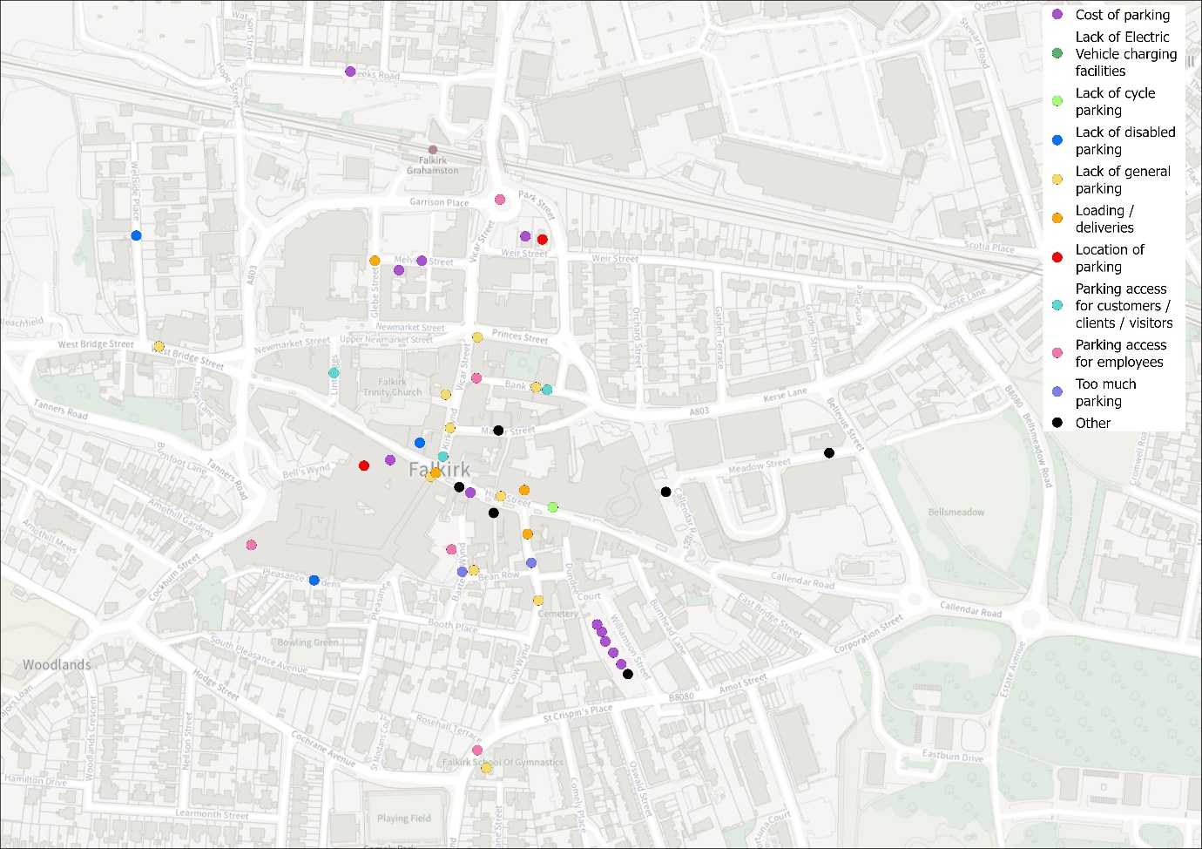
A summary of the problems identified are summarised below.

The main locations where problems were raised were as follows:
- Williamson Street Car Park- concerns around parking cost and duration of stay options available.
- Manor Street / Bank Street / Vicar Street- there was a general concern around the lack of general parking, with a perception that there is too much disabled parking and not enough parking availability for employees.
- Cow Wynd- issues such as lack of space for loading / deliveries, lack of general parking and too much parking for disabled users.
Summary of Opportunities
Respondents identified location-specific opportunities related to parking, which are shown spatially in the map below.
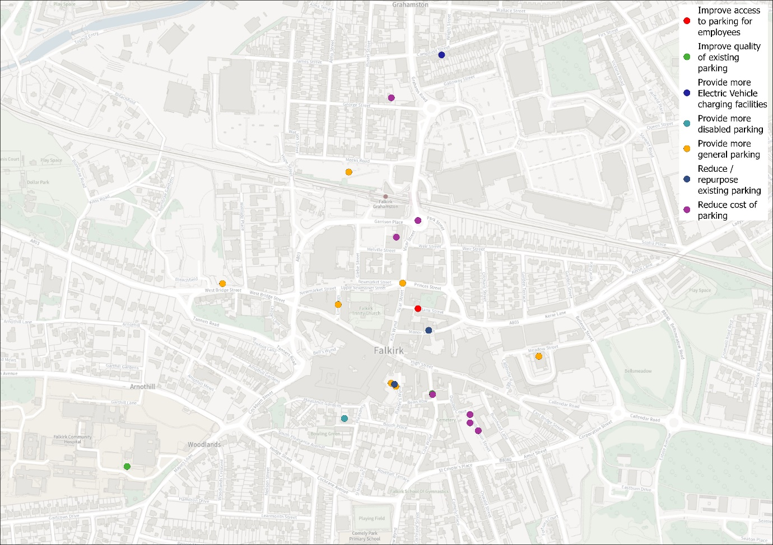
A summary of the opportunities identified are summarised below.

The main locations where opportunities were suggested were as follows:
- Williamson Street Car Park- opportunity to review the cost and duration of stay options at this location.
- Manor Street / Bank Street- opportunity to repurpose existing disabled parking to provide more general parking.
- Baxters Wynd- opportunity to provide more general parking. All parking provision at this location is disabled parking only.
Parking Priorities
Businesses were asked to state their top 3 priorities as a business related to parking. The top 3 most popular responses included ‘parking access for customers / clients / visitors’ (25%), ‘parking access for employees’ (24%) and ‘cost of parking’ (16%).

Summary
A summary of the key themes identified through responses to this survey is provided below.
- Cost of parking- this was raised as a general issue throughout Falkirk town centre, with particular locations regularly raised including Williamson Street car park and Melville Street.
- Provision of general parking- there were multiple locations where a lack of general parking was identified, and where general parking could be introduced, including Cow Wynd, Baxter’s Wynd Manor Street, Bank Street and Vicar Street
- Parking access for customers, clients, visitors and employees- the same locations as above were identified as not having enough parking for use of local employees.
It is therefore clear that key themes such as cost of parking, provision of more general parking and ensuring parking access for customers, clients, visitors and employees should be considered to help inform this strategy.

